GENI Lab 6 (**Not for Submission**)

Name: Johnnie Oldfield

Student #:

Login to nodes:

Client login: ssh jboldfie@pc2.instageni.rnoc.gatech.edu -p 25810

Server login: ssh jboldfie@pc2.instageni.rnoc.gatech.edu -p 25811

Internet

Control Plane Switch

Client

Data i/f: eth1

ip: 10.10.1.2

Data i/f: eth1

ip: 10.10.1.1

Server

Data Plane Switch

Control i/f: eth0

ip: 172.17.2.3

Control i/f: eth0

ip: 172.17.2.2

Answer the following questions from “GENI-lab6-Instruction”

We are going to change both the RTT and TCP window size and see how the TCP throughput reacts.

On server,

sudo tc qdisc del dev <interface name> root

sudo tc qdisc add dev <interface name> root netem delay 200ms

ping client -c 5

iperf -s -w 4KB

Then on client,

ping server –c 5

iperf -c server ‐t 10 -w 4KB

On server, stop the iperf server,

sudo tc qdisc del dev <interface name> root

What is the average bandwidth (i.e. the actual throughput) of this link? 118 Kbits /sec

What is the average RTT between the client and the server connection by this link? 200 ms = .2 sec

What is the TCP window size of this link? 8.00 Kbyte = 64Kbits

What is the theoretical maximum throughput = Window Size/RTT of this link? 320 Kbits/sec

**Note: The actual throughput should always be less than the theoretical maximum throughput.**

Attach screenshot of the client ssh terminal:

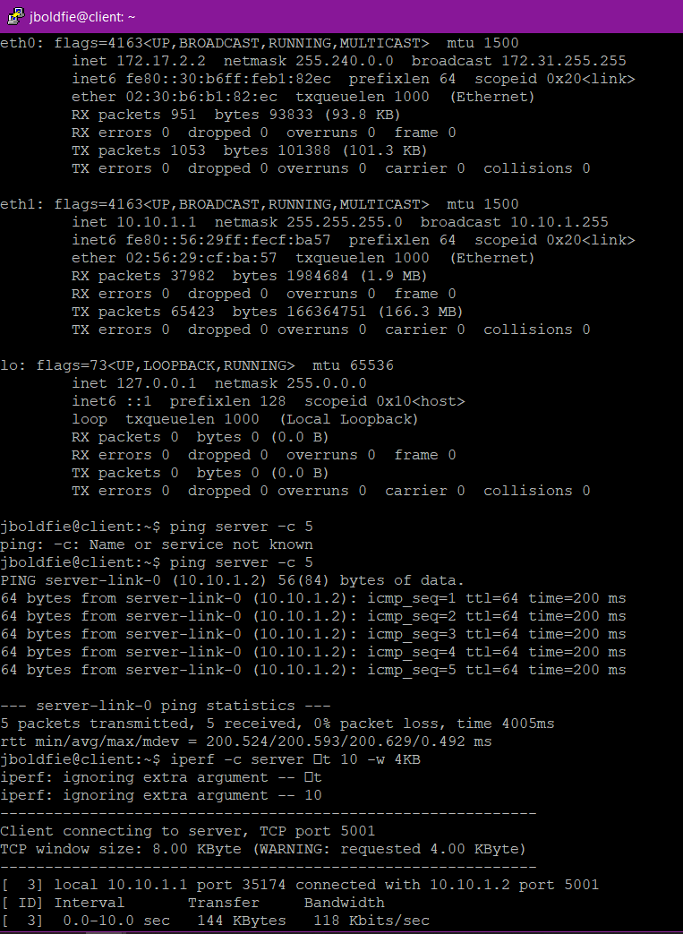

Attach screenshot of the server ssh terminal:

